Dis-Asia-Indus Valley-Mohenjodaro-Male Torso-Steatite-2000 BCE

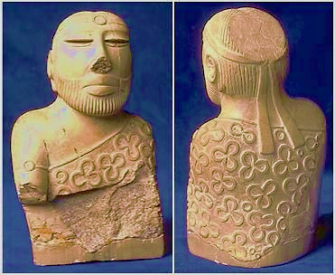 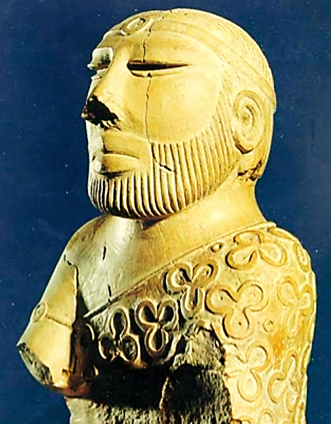

Figs. 1-3. Indus Valley-Mohenjodaro-Male Torso-Steatite-2000 BCE, front, rear and ¾ left side. Replica of original male torso from Mohenjodaro. National Museum of Karachi. Now damaged in front and on the rear pate. Images of original from <https://www.sindhidunya.com/wp-content/uploads/2015/04/4500-years-old-Statue-of-Parohat-Raja.png>

**Case no.: 2**

**Accession Number:**

**Formal Label:** Indus Valley-Mohenjodaro-Male Torso-Steatite-2000 BCE

**Display Description:** Physical traits of the individual include a low forehead, a broad nose, thick lips, partially closed eyes (which may suggest a meditative pose). His sarong has interconnected trefoil, duofoil and circular ornament designs and each type of these images has a center-point.

 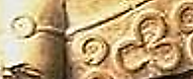 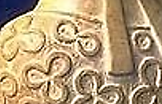

Fig. 3. Front, detail of headband (center–point circle)

Fig. 4. Front, detail of arm band (center–point circle) and sarong designs (center-point circles, trefoils)

Fig.5. Rear, detail of headband draped over sarong with the three center–point circle types (trefoil, duofoil, and single center-pont circle.

Each of these designs had been painted red with cinnabar or red ochre indicating ritual significance. His head gear, arm band and sarong display the same circular ornament with a pointed center that may represent a gem stone. His beard and head had been meticulously combed suggesting an élite cultural affiliation.

**LC Classification:**

**Date or Time Horizon:** 2000 BCE

**Geographical Area:** Indus Valley, Mohenjodaro site.

**Map, GPS coordinates:**

**Cultural Affiliation:**

**Media:** steatite, red pigment (cinnabar or red ochre)

**Dimensions:**

**Weight:**

**Condition: Original:** Now damaged in front and on the rear pate.

**Provenance:** Original: National Museum of Karachi

**Discussion:**

The four principles in Hinduism are called [Puruṣārtha](https://en.wikipedia.org/wiki/Puru%E1%B9%A3%C4%81rtha) and encompass the following (Chatterjee 2003).

The first principle is [moksha](https://en.wikipedia.org/wiki/Moksha) ([Sanskrit](https://en.wikipedia.org/wiki/Sanskrit_language): मोक्ष, *mokṣa*) which deals with one’s personal spiritual emancipation which has two dimensions: 1. [eschatological](https://en.wikipedia.org/wiki/Eschatology)ly ([Greek](https://en.wikipedia.org/wiki/Ancient_Greek) [ἔσχατος](https://en.wiktionary.org/wiki/%E1%BC%94%CF%83%CF%87%CE%B1%CF%84%CE%BF%CF%82) *eschatos* = end point) freedom from *[saṃsāra](https://en.wikipedia.org/wiki/Sa%E1%B9%83s%C4%81ra" \o "Saṃsāra)*, the cycle of death and rebirth. 2. Epistemologically ([Greek](https://en.wikipedia.org/wiki/Greek_language" \o "Greek language) [ἐπιστήμη](https://en.wiktionary.org/wiki/%E1%BC%90%CF%80%CE%B9%CF%83%CF%84%CE%AE%CE%BC%CE%B7)*, episteme*= knowledge) freedom from ignorance, self-realization and self-knowledge. Meditation aims to realize one's self in union with one's Ātman and [Brahman](https://en.wikipedia.org/wiki/Brahman) (the [Absolute](https://en.wikipedia.org/wiki/Absolute_(philosophy))). The [six orthodox schools of Hinduism](https://en.wikipedia.org/wiki/Hindu_philosophy) believe that there is Ātman (Soul, Self) in every being, a major point of difference with [Buddhism](https://en.wikipedia.org/wiki/Buddhism), which does not believe that there is either soul or self.

The other three principls are [*dharma*](https://en.wikipedia.org/wiki/Dharma) (virtuous, proper, moral fulfillment of one’s personal life), [*artha*](https://en.wikipedia.org/wiki/Artha) (physical means of sustaining one’s personal life), and [*kama*](https://en.wikipedia.org/wiki/Kama) (emotional fulfillment of one’s personal life) (Sharma 1982, 1999). Together, these are the four aims of life.

It is possible that the trefoil design symbolizes these latter three goals and that the single circle refers to moksha. If this hypothesis is correct moksha is the symbol found on the arm band and on the head band of this male steatite torso. Hence this individual would be an accomplished and recognized Proto-Hindu master.

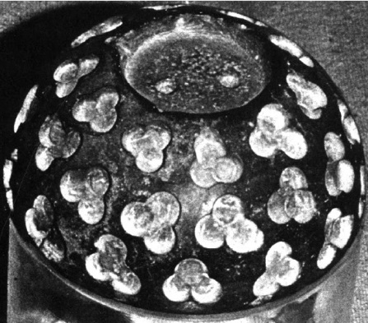

Fig. 7. Ritual bowl, ca 2000 BCE, showing trefoil design. National Museum of Karachi, Pakistan. In this trefoil design there is a distinct merger of the three center-point circles as on the Male Steatite torso from Mohenjodaro, 2000 BCE, possibly symbolizing 3 of proto-Hinduism’s four principles.

**References:**

**References:**

T. Chatterjee, T. 2003. *Knowledge and Freedom in Indian Philosophy*.

Sharma. A. 1982. The Puruṣārthas: a study in Hindu axiology, Michigan State University. pp 9-12.

Sharma. A. 1999. [The Puruṣārthas: An Axiological Exploration of Hinduism](http://www.jstor.org/stable/40018229), The Journal of Religious Ethics, Vol. 27, No. 2 (Summer, 1999), pp. 223-256;